Introduction
This is the Github repository where all the code, config files and docker-compose files can be found.

Orion context broker & QuantumLeap
Orion Context Broker is a C++ implementation of the NGSI-LD REST API binding within the FIWARE platform. It acts as a server that manages the lifecycle of context information, allowing users to create, update, query, and subscribe to context elements.
FIWARE QuantumLeap is a time-series data persistence enabler designed to store, query, and retrieve NGSI (Next Generation Service Interface) data, particularly useful for IoT and smart city applications. It acts as a bridge between the FIWARE platform and time-series databases like CrateDB and Timescale, allowing for the historical context data to be stored and queried.
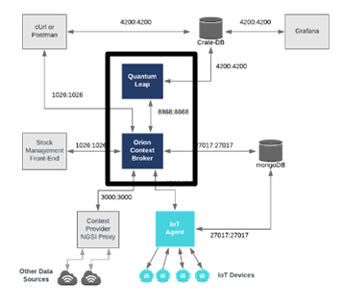
Run the docker compose to install the following containers:
FiWare Orion (context broker)
MongoDB (storage context data)
FiWare QuantumLeap (persist data)
CrateDB (storage for QL)
Chosen DataModel:
smart-data-models/dataModel.Streetlighting: Streetlighting Data Model
Create identities with PostMan:  Streetlights | curl --location 'http://192.168.1.234:1026/ngsi-ld/v1/entities' \  --header 'Content-Type: application/ld+json' \  --data-raw '{  "@context": "https://smart-data-models.github.io/dataModel.Streetlighting/context.jsonld",  "id": "urn:ngsi-ld:Streetlight:Helmond-Kasteel-008",  "type": "Streetlight",  "location": {  "type": "GeoProperty",  "value": {  "type": "Point",  "coordinates": [  8.662,  51.490  ]  }  },  "illuminance": {  "type": "Property",  "value": 800,  "unitCode": "LX"  },  "powerState": {  "type": "Property",  "value": "on"  },  "address": {  "type": "Property",  "value": {  "streetAddress": "Kasteel-Traverse",  "addressLocality": "Helmond",  "addressRegion": "Noord-Brabant",  "addressCountry": "NL",  "postalCode": "5701NR"  }  },  "dateInstalled": {  "type": "Property",  "value": {  "@type": "DateTime",  "@value": "2022-10-26T21:32:52Z"  }  },  "controlledAsset": {  "type": "Relationship",  "object": "urn:ngsi-ld:LightController:controller-A-456"  }  }'
Check identities with PostMan:
Streetlights
Update values of an identity with PostMan.  Return “204 No Content” is ok. | curl --location --request PATCH 'http://192.168.1.234:1026/ngsi-ld/v1/entities/urn:ngsi-ld:Streetlight:Helmond-Kasteel-008' \  --header 'Content-Type: application/ld+json' \  --data-raw '{  "@context": "https://smart-data-models.github.io/dataModel.Streetlighting/context.jsonld",  "illuminance": {  "type": "Property",  "value": 790,  "unitCode": "LX"  }  }'
Read attributes of a specific identity with PostMan.  Return “200 OK” is ok. | curl --location 'http://192.168.1.234:1026/ngsi-ld/v1/entities/urn:ngsi-ld:Streetlight:Helmond-Kasteel-008' \  --header 'Accept: application/ld+json'
Read a specific attribute of a specific identity with PostMan.  Return “200 OK” is ok. | curl --location 'http://192.168.1.234:1026/ngsi-ld/v1/entities/urn:ngsi-ld:Streetlight:Helmond-Kasteel-008?attrs=illuminance' \  --header 'Accept: application/ld+json'
To store data persistent via QuantumLeap in the CrateDB, you have to create a subscription into QL with PostMan.  Return “201 Created” is ok.  Note: QL does not support full NSGI-LD. So this subscription will send dat in NGSI-V2 format. | curl --location 'http://192.168.1.234:1026/ngsi-ld/v1/subscriptions' \  --header 'Content-Type: application/ld+json' \  --data-raw '{  "@context": "https://smart-data-models.github.io/dataModel.Streetlighting/context.jsonld",  "description": "Hybrid Subscription: LD request, v2 notification",  "type": "Subscription",  "entities": [  {  "type": "Streetlight"  }  ],  "notification": {  "format": "normalized",  "endpoint": {  "uri": "http://quantumleap:8668/v2/notify",  "accept": "application/json"  }  }  }'
Check if data is stored persistent in QL via PostMan.  Return “200 OK” is ok. | curl --location 'http://192.168.1.234:8668/v2/entities/urn:ngsi-ld:Streetlight:Helmond-Brandevoort-003' \  --header 'Accept: application/json'

KeyRock
Keyrock is the FIWARE's Identity Management (IDM) component. It's used to manage user identities and applications, enabling OAuth 2.0-based authentication and authorization for services and applications. Keyrock facilitates user registration, organization management, and application registration, providing both a GUI and API interface.
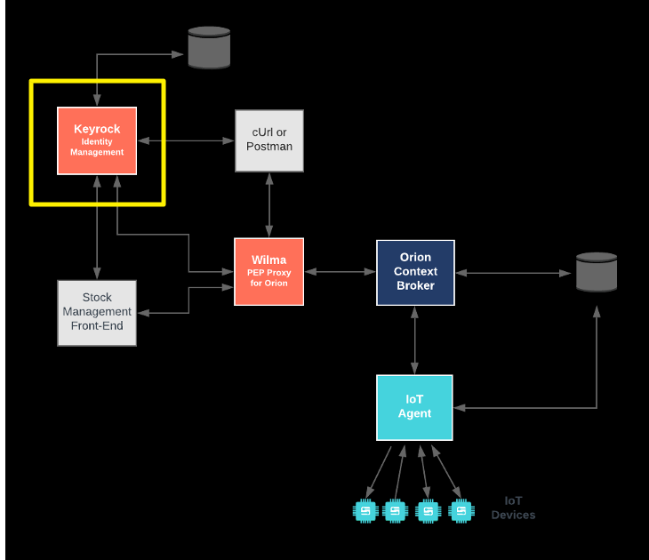
Install KeyRock with the docker-compose.yml file.
Login to the Keyrock GUI.  Create a test user. | 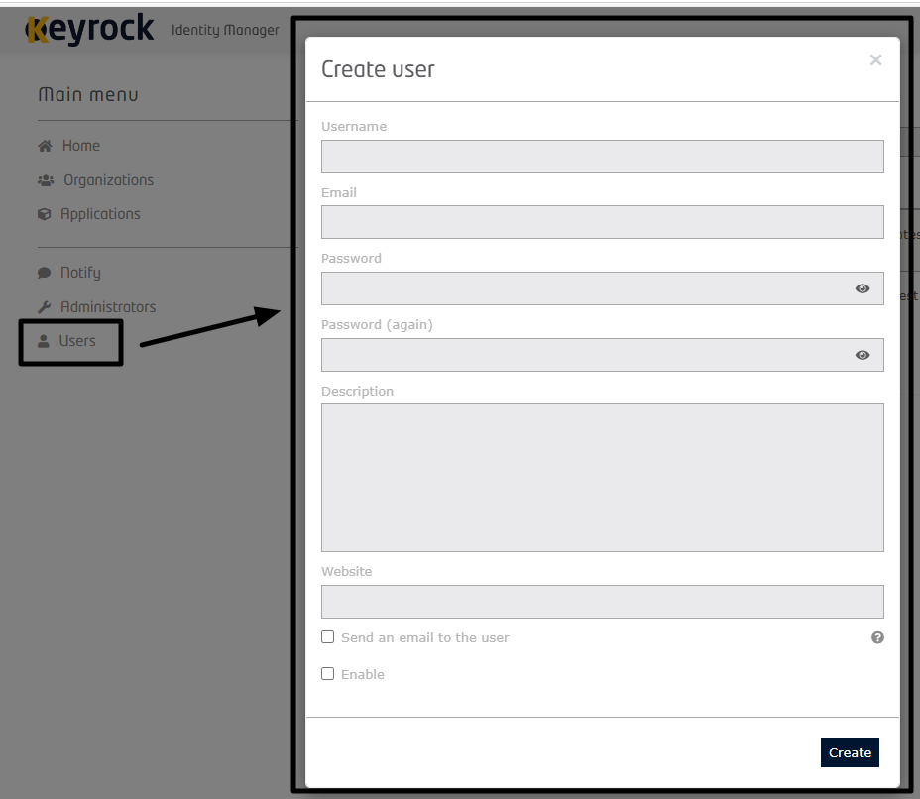
For every API that you want to authenticate with, you have to create an application. | 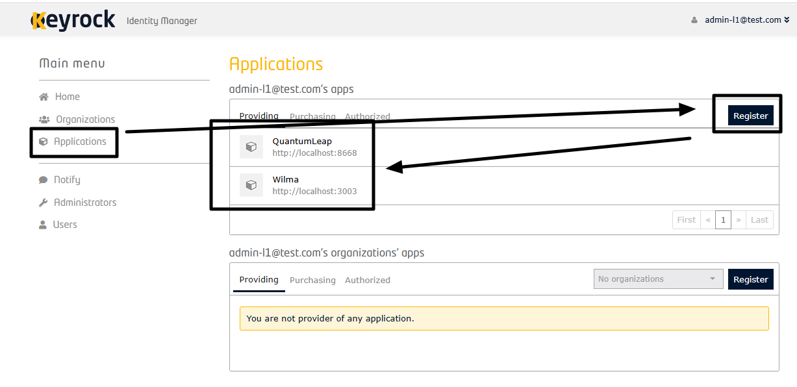

Wilma PEP Proxy
In this tutorial it will be explained how to configure a Wilma PEP Proxy for Orion. You can follow the same steps for QuantumLeap. This must be done on another instance.
A Wilma PEP Proxy is a software component used within the FIWARE architecture to enforce access control to backend applications. It acts as a middleman, intercepting requests and making authorization decisions before they reach the actual service.
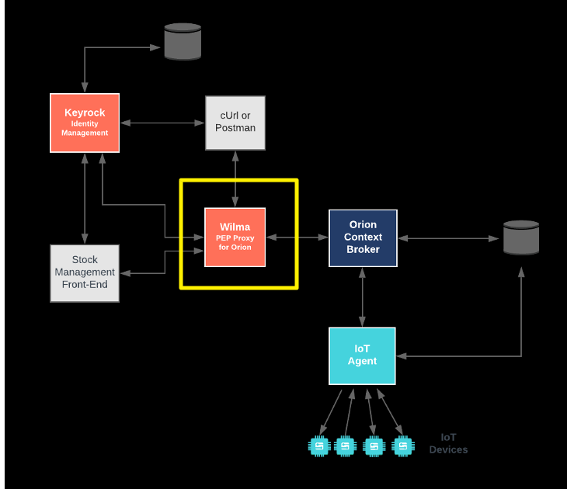
Create an application for the Wilma PEP Proxy in KeyRock first. | 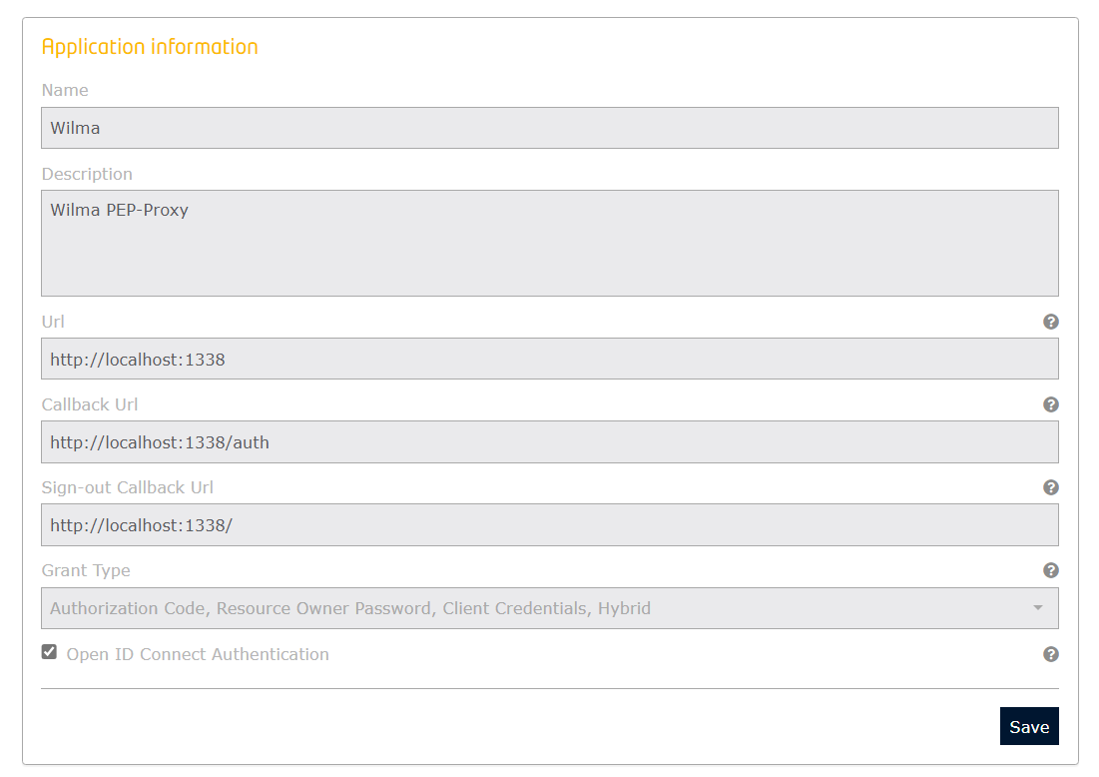
Set token type to JWT. | 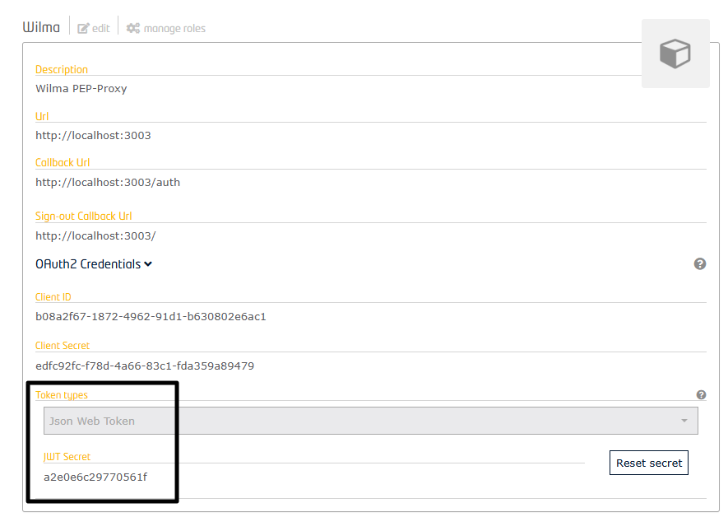
Register the PEP Proxy | 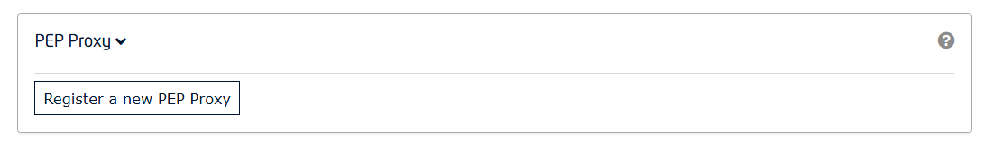
Use these credentials in the config.js for the Wilma PEP Proxy environment values. | 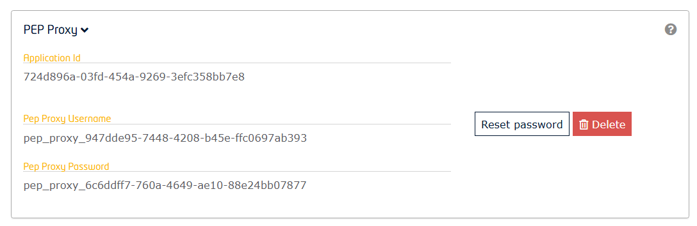
Authorize this user for the application. | 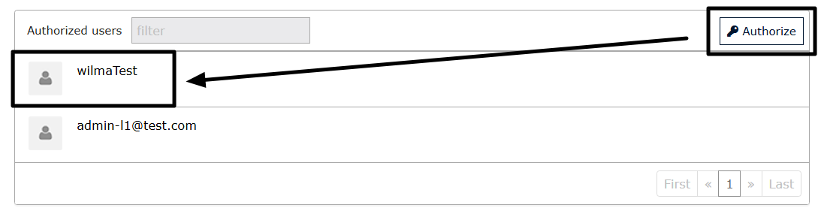
Create a permission to access entities data in Orion. | 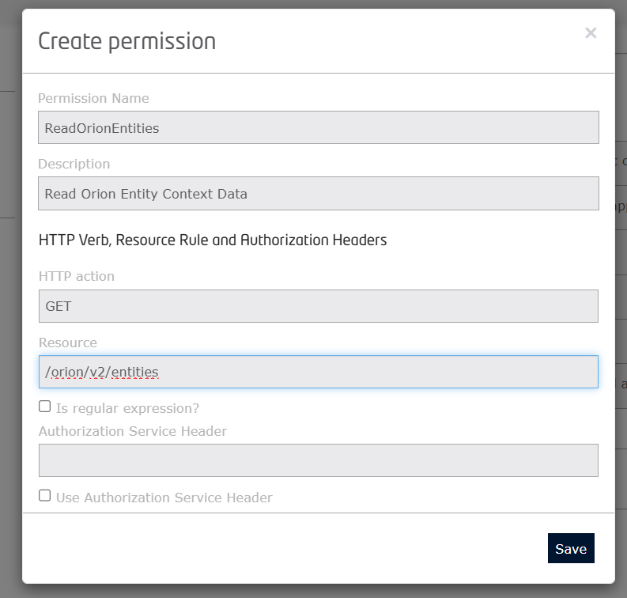
Create a role and assign the permission. | 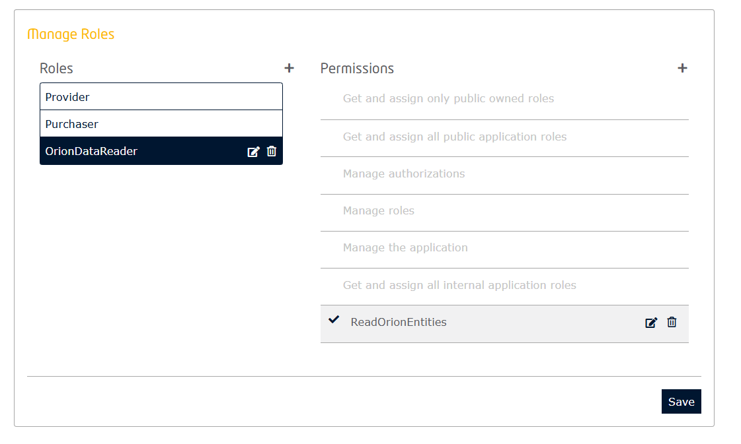
In the application, assign the role to the user. | 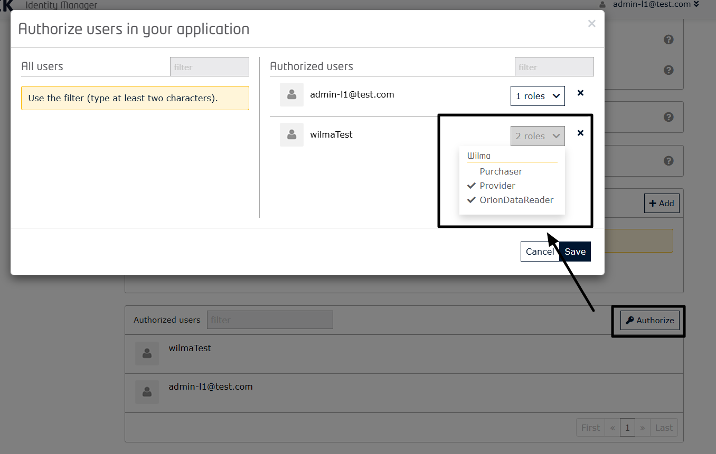
Write your config.js file.  Drop the file in the same directory as the docker-compose.yml. | 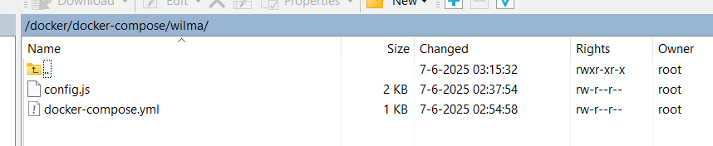
Install the Wilma PEP Proxy with the docker-compose file.
Read attributes of a specific identity through Wilma with PostMan.  Return “200 OK” is ok. | curl --location 'http://192.168.1.234:3003/ngsi-ld/v1/entities/urn:ngsi-ld:Streetlight:Helmond-Kasteel-008' \  --header 'X-Auth-Token: b47e0a74424fd9c8b1b2c708c5e6927ee8057b92' \  --header 'Accept: application/ld+json'
Read a specific attribute of a specific identity through Wilma with PostMan.  Return “200 OK” is ok. | curl --location 'http://192.168.1.234:3003/ngsi-ld/v1/entities/urn:ngsi-ld:Streetlight:Helmond-Kasteel-008?attrs=illuminance' \  --header 'X-Auth-Token: b47e0a74424fd9c8b1b2c708c5e6927ee8057b92' \  --header 'Accept: application/ld+json'

Sources
tutorials.NGSI-LD/docs/roles-permissions.md at master · FIWARE/tutorials.NGSI-LD

